**NAME:** ALLAINEA R. ATENDIDO **COURSE/YEAR/SECTION:** BSIT-II-B **DATE:** 03/23/2022

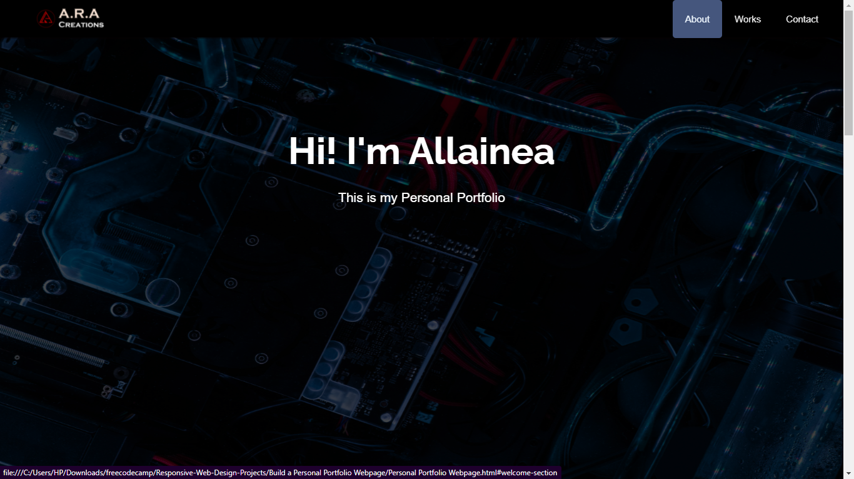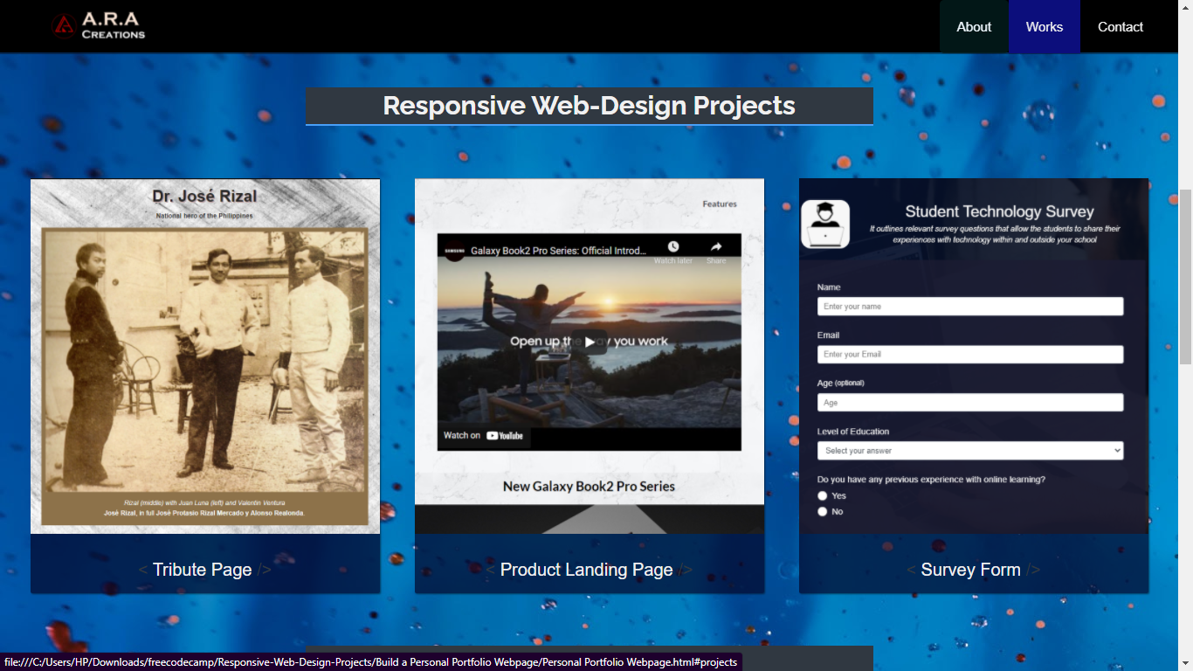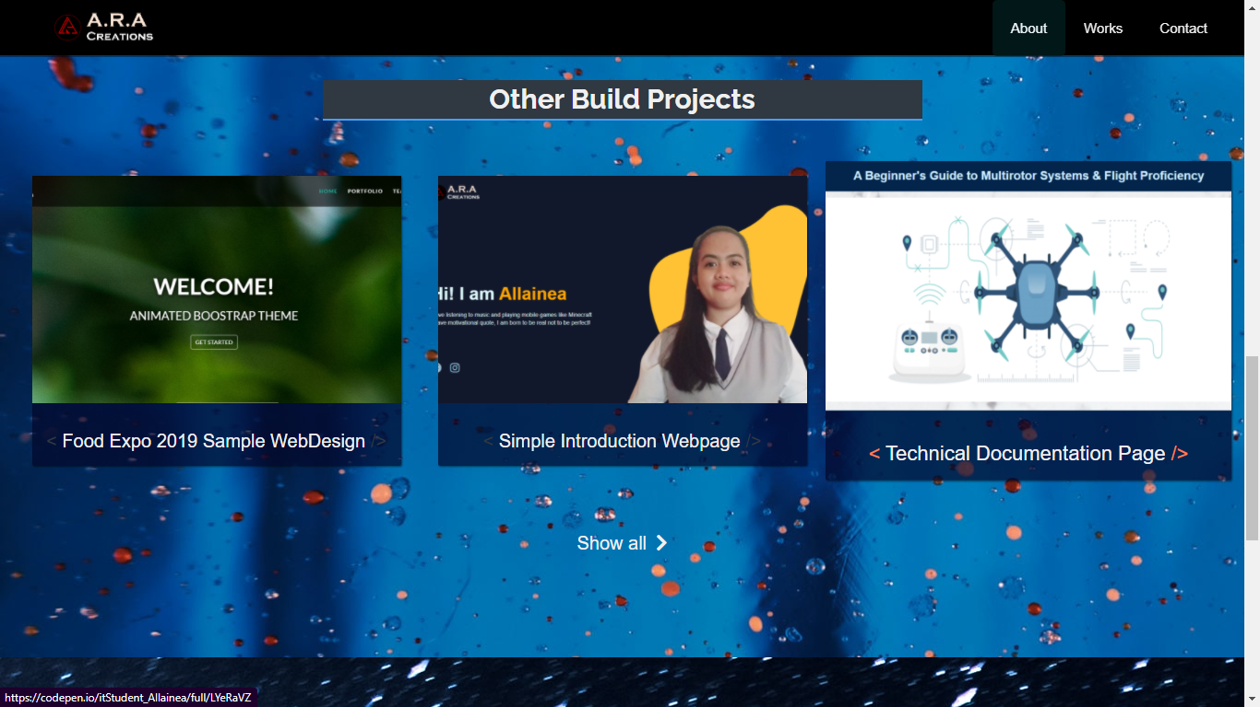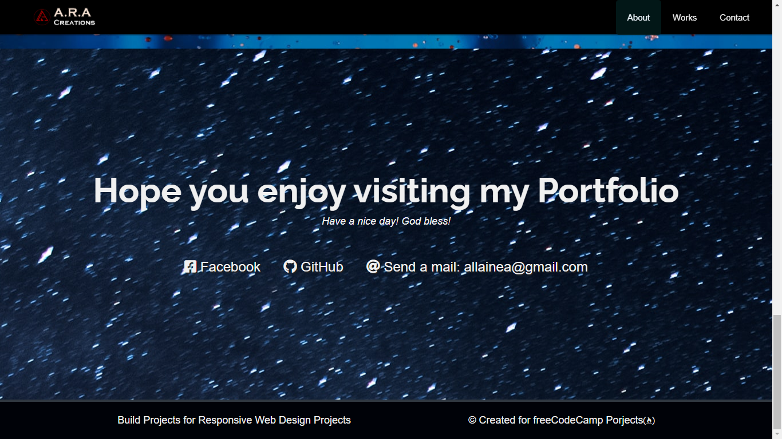

**FREECODECAMP LINK:** <https://codepen.io/itStudent_Allainea/full/eYyORjm>